**HOSTEL MANAGEMENT**

**Submitted by:**

|  |  |
| --- | --- |
| Darshan P.S | 1JS20CS055 |
| Chidanand S.V | 1JS20CS050 |

**Create table commands:**

SQL> create table student(Sid varchar(10) primary key,

2 sname varchar(20),

3 saddress varchar(20),

4 Gender varchar(5),

5 age int);

SQL> create table hostel(Hid varchar(10) primary key,

2 Hname varchar(20),

3 Haddress varchar(20),

4 No_ofRooms int,

5 city varchar(10),

6 rating int );

SQL> create table rooms (

2 rid varchar(10) primary key,

3 hid varchar(10) references hostel(hid) on delete cascade,

4 type varchar(10) ,

5 cost varchar(10));

SQL> create table payment(

2 pid varchar(10) primary key,

3 hid varchar(10) references hostel(hid),

4 rid varchar(10) references rooms(rid),

5 sid varchar(10) references student(sid),

6 amt_paid int);

SQL> create table food(

2 hid varchar(10) references hostel(hid),

3 quality varchar(10),

4 fcost varchar(10),

5 veg_nonveg varchar(10));

**Description commands:**

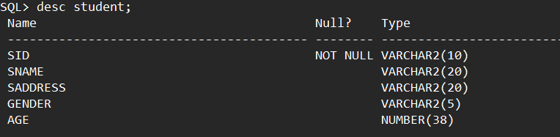

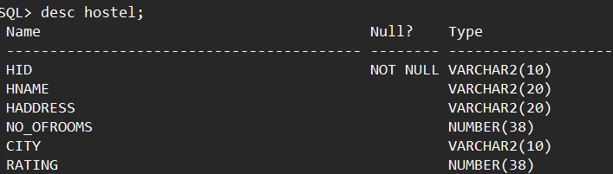

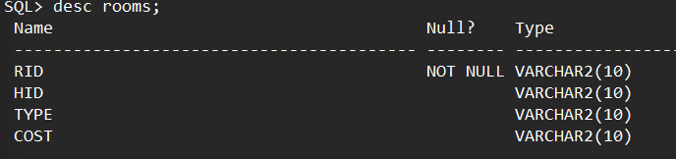

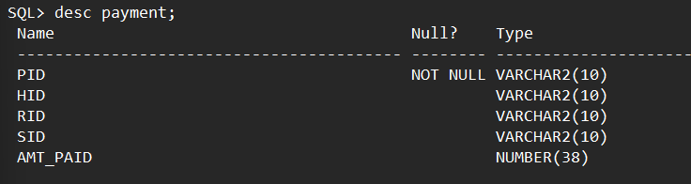

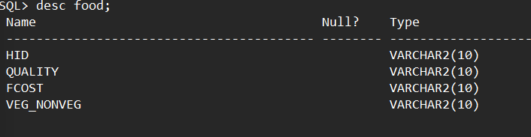

**Tables:**

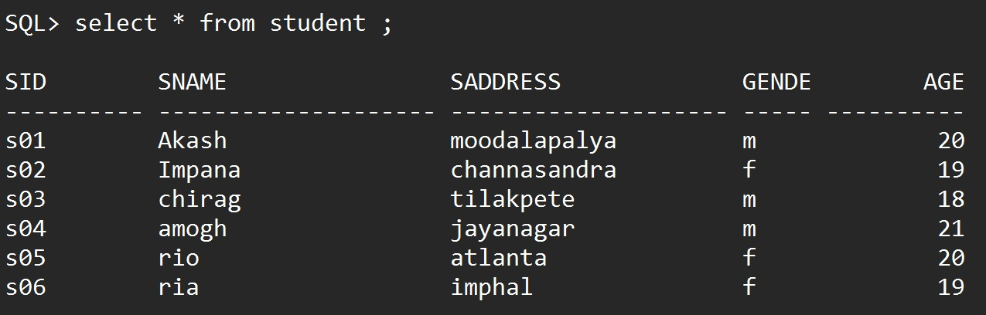

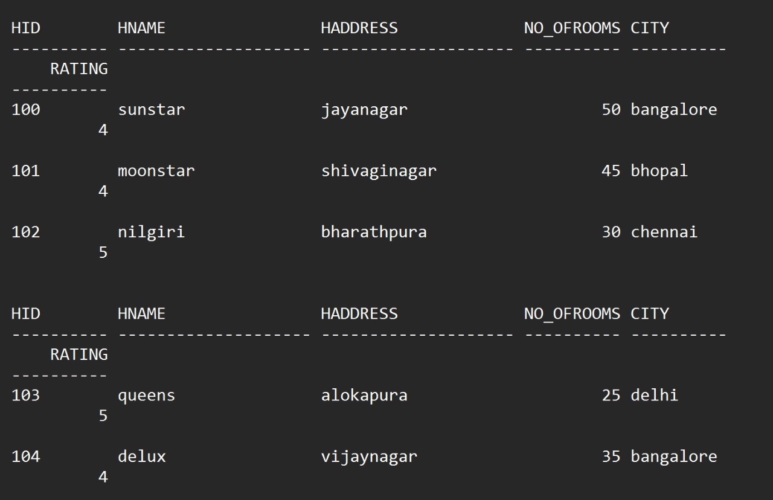

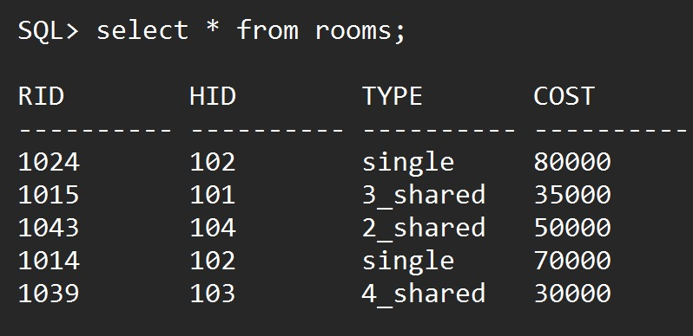

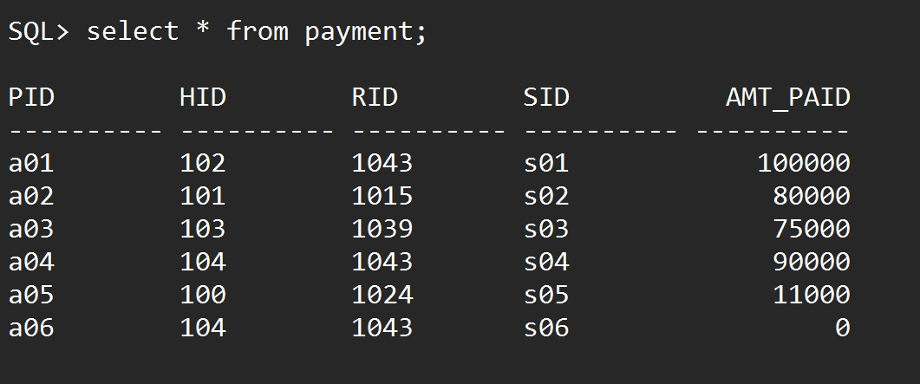

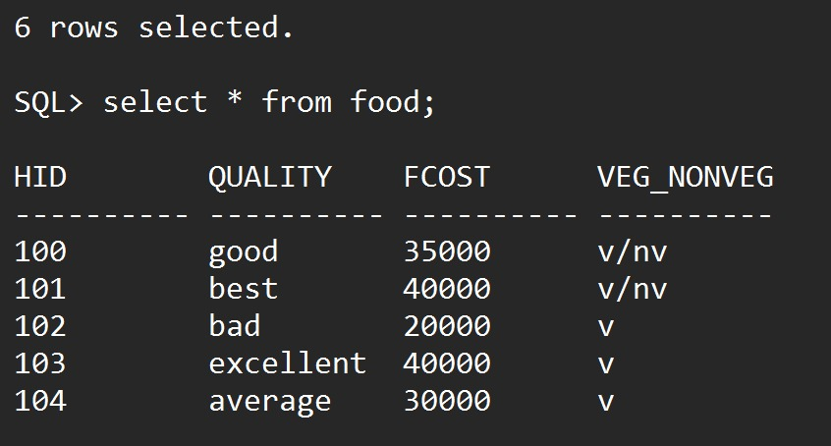

**Queries:**

1. List the students name who has not paid the amount.

SQL> select sname from

2 student s,payment p

3 where s.sid=p.sid and

4 p.amt_paid=0;

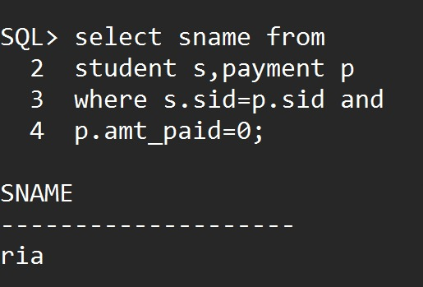

1. List the student details who have booked the same room.

SQL> select s.* from

2 student s,payment p

3 where s.sid=p.sid and

4 p.rid in(select rid from payment

5 group by rid

6 having count(*)>1);

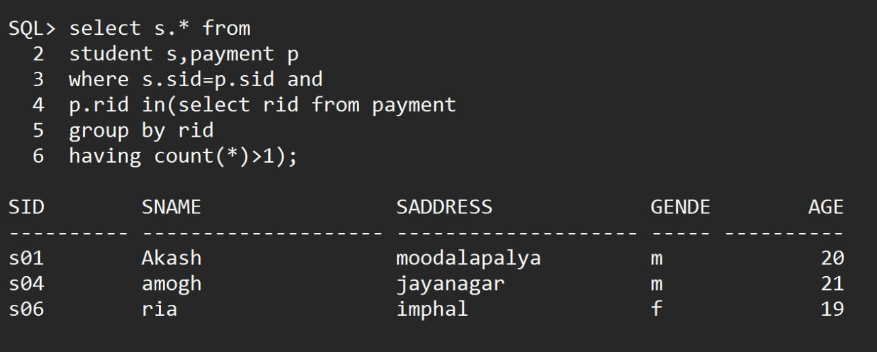

1. List the hostel names which serves both veg and non-veg.

SQL> select hname from

2 hostel h,food f

3 where h.hid=f.hid and

4 f.veg_nonveg='v/nv';

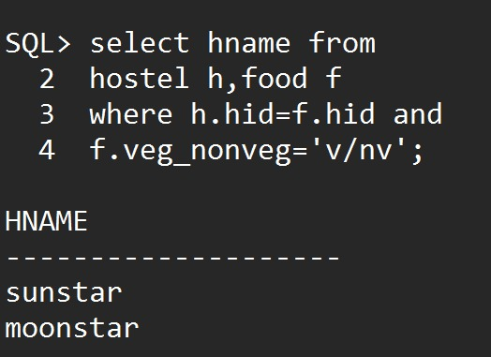

**4**. List the hostel name located in Bangalore and having more than 20 rooms

SQL> select hname from

2 hostel where

3 city='bangalore' and

4 no_ofrooms>20;

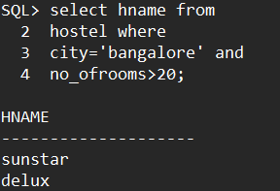

**5**. Select the hostel name and its food details whose rating is more than 2 and food cost is less than 40000

SQL> select h.hname,h.rating,f.quality,f.fcost

2 from hostel h,food f where

3 h.hid=f.hid and

4 h.rating>2 and

5 f.fcost<40000;

